Tax Cuts Data – Good Idea?
Unemployment Rate
Unemployment Rate = 4.5%
Oregon Unemployment Rate = 4% (record low)

Economic Growth Rate
U.S. 2016 = 1.6%
World 2016 = 3.4%

Inflation Rate
U.S. = 2%
U.S. Central Bank Target = 2%

Gini Coefficient
U.S. = 0.39
Developed country average = 0.31

U.S. Debt
$19.9 trillion

U.S. Budget Deficit
$352 billion

U.S. Personal Income Tax Rates:
Top rate Canada = 58.75%, Top Rate Israel = 50%, Top Rate Cayman Islands = )%

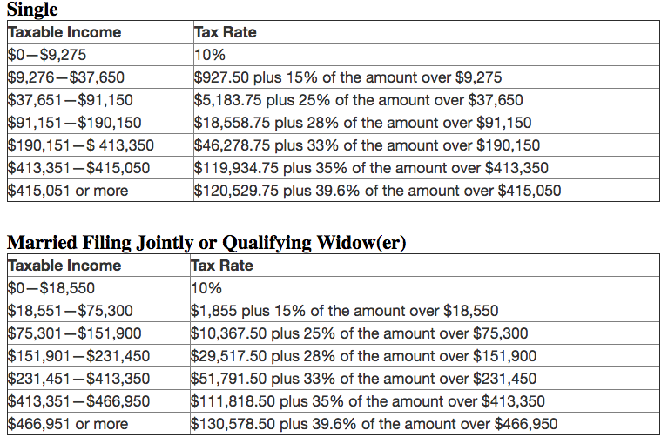

Corporate Income Tax Rate

35% where taxable income exceeds $335,000.

